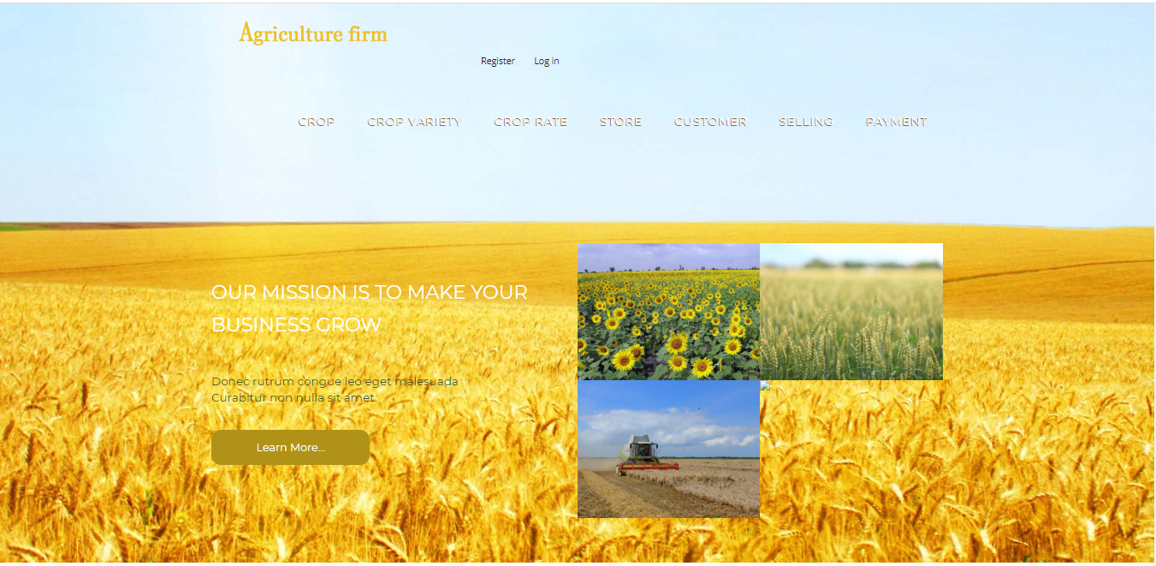

The goal of the seed management is to provide the different kind of services to the customers. In this software there are much type of forms like Crop, Crop variety, Crop Rate, Store, Customer, Selling and Payment where you can add update these things. This software is very user friendly software. The customer can easily manage this kind of software. I have described the all functionality of my software under as:-

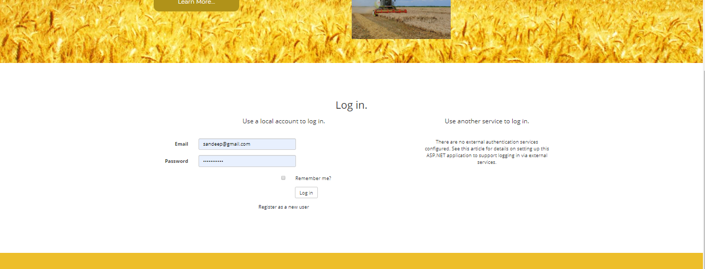

First of all User will have to fill the login credentials to enter in the project so he or she will have to fill the Email and password. If he or she fill the credentials then he will enter in the software.

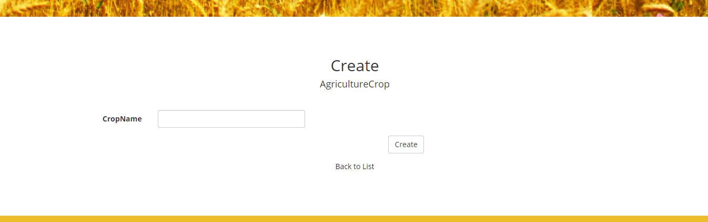

Once User login the credentials then he or she will enter in the project then he will have to add the crop name. when he add the the crop name and save it then list will open like this:

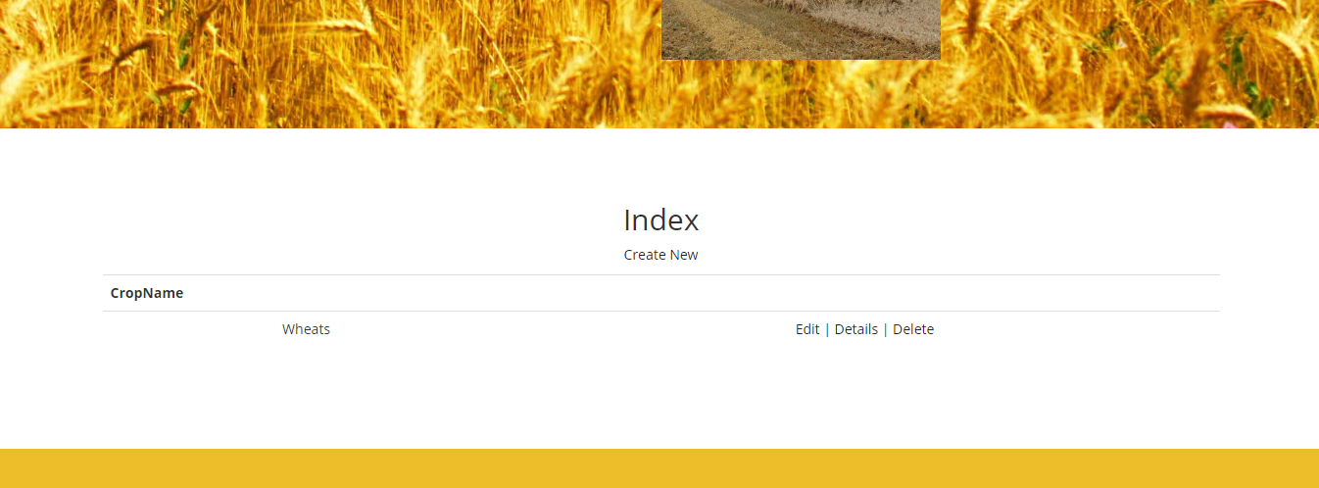

The user can add or delete the record in the list by clicking on the buttons which are showing on the list. When he or she click on the edit button. Then below form will open.

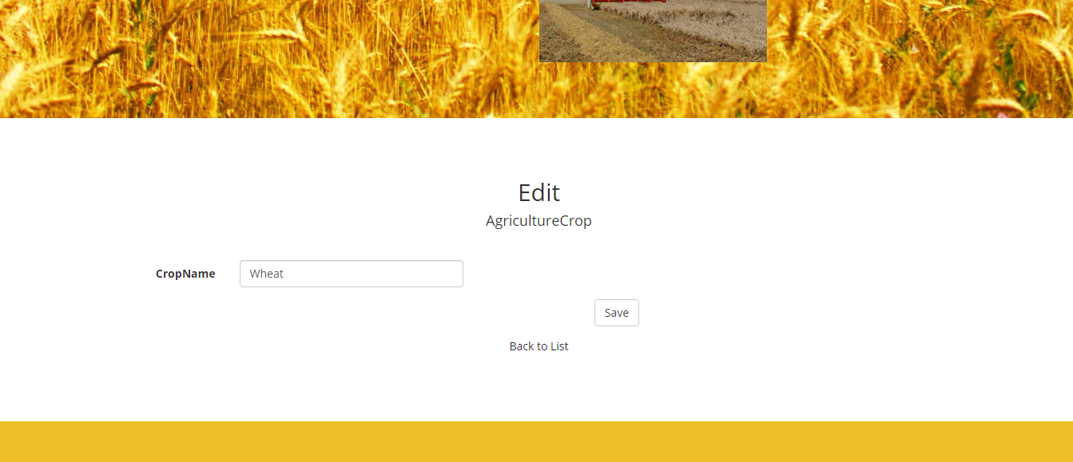

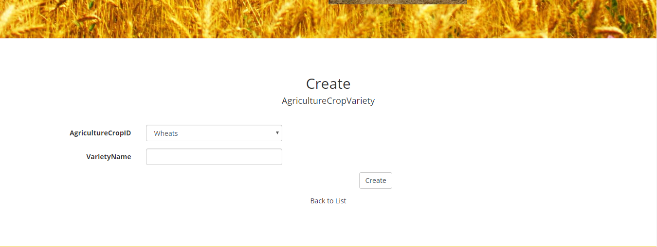

In this from user can add variety of the crop. Here the agriculture crop is coming from crop fields. Here user can select type of crop. When he or she add the variety then list will be shown like:

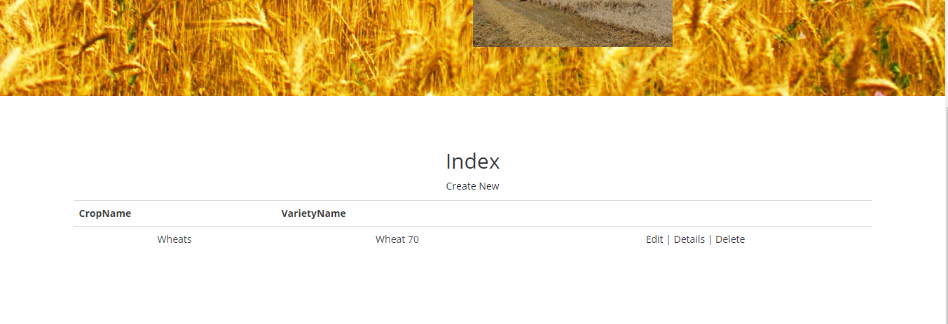

This is list of varieties of the wheats.here we enter the variety like wheat 70. Here user can edit and delete the variety.

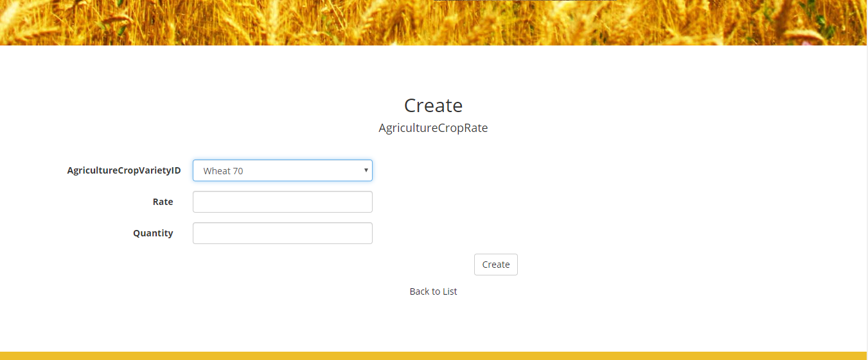

Here user can add agriculture crop rate and quantity.

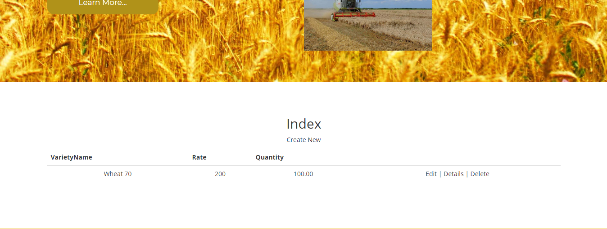

Which rate and quantities are added in the form these entries are showing in this list.

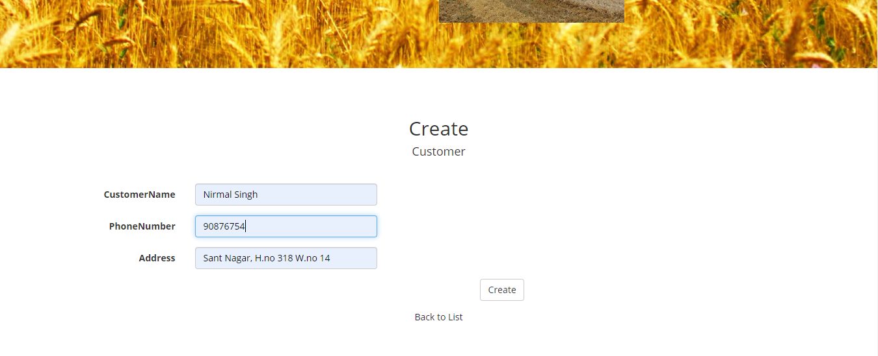

Here we can add customer details

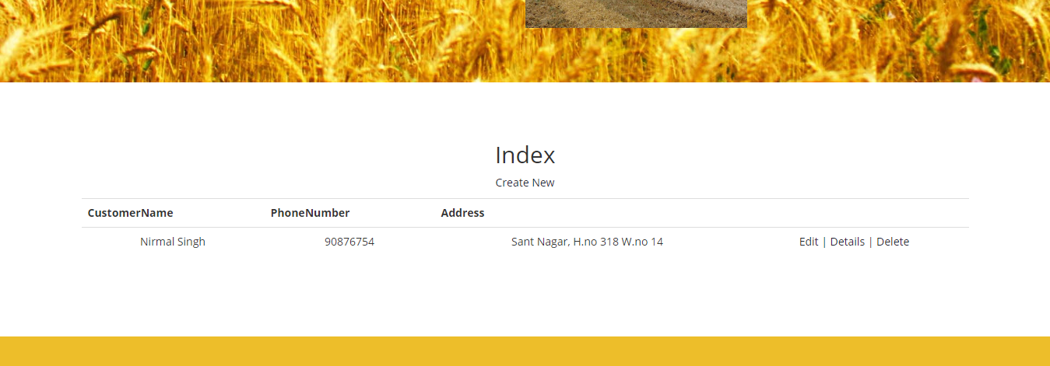

This is list of customers.

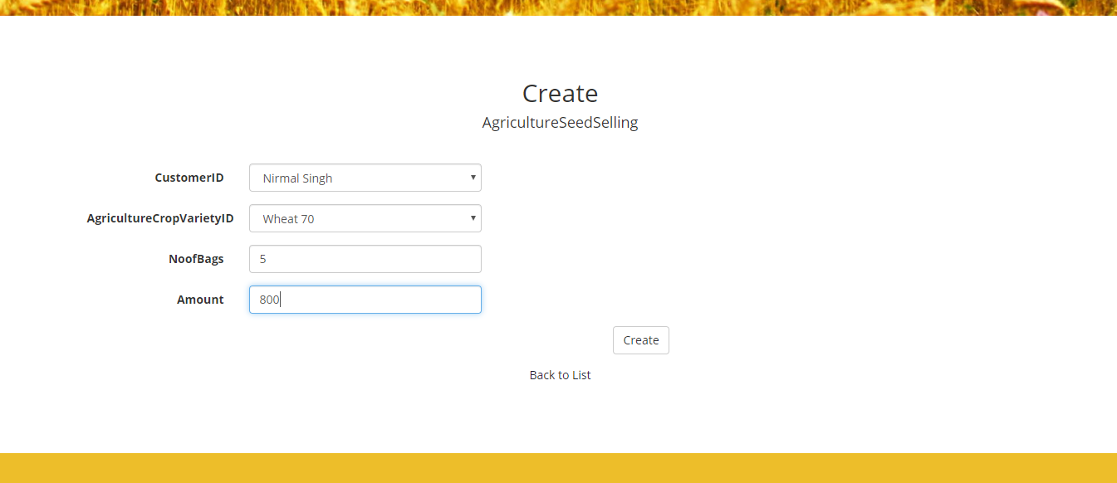

This is selling page for selling the seeds.

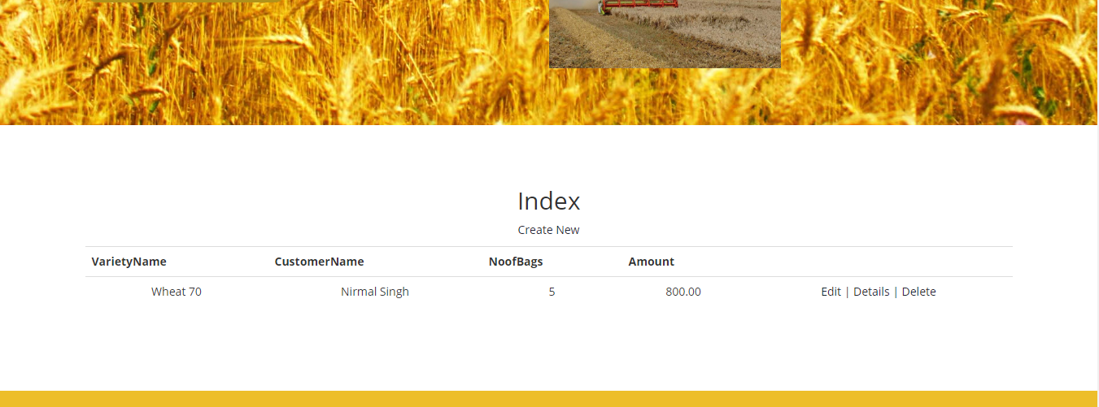

This is selling seed list.